Solar Cell Assembly
Summary of Tecstar and TRW visits

USUSat

Kenneth Vanhille

October 2, 2000
Summary of visits to TECSTAR and TRW

September 26, 2000 Ken Vanhille (Utah State University) represented ION-F in a visit to TECSTAR and TRW in the Los Angles area. These visits were necessary to enable ION-F a better understanding of the procedure needed to assemble the solar strings and arrays once TECSTAR delivers the solar cells that have been ordered. Robert Langdon has been the ION-F contact at TECSTAR for the solar cell order. He arranged for a meeting with Jim Hanley, Director of Solar Panels, at the aforementioned company. Marshall Cannedy, Director of Solar Panelsat TRW, welcomed Ken Vanhille and Dr. Charles Swenson for a discussion and tour of their facilities.
TECSTAR sat down and outlined the entire process necessary for the construction of solar panels. This process starts with receiving the CICed cell and continues all the way through testing the assembled panels. The acronym CIC stands for Coverglass/Interconnect/Cell, which refers to the condition of the solar cells that we will be receiving. The following information will be a synopsis of the process outlined by TECSTAR with additional insights from Marshall Cannedy as well. Prices on all of these items have not been included, but they will be included in subsequent revisions.

Assembly of Strings
Assembly of the strings is the first task that ION-F will encounter once the cells are received. String assembly in industry is done by welding, a process that has been taking over in the last 5 years. ION-F will use soldering, which is still used for manual touch-up jobs. Welding needs facilities that are much more elaborate than anything that is conceivably possible for the resources of ION-F. Soldering should be done using a Sn 62 wire. This wire contains 62.5% tin, 36.1% lead and 1.4% silver. This alloy is more desirable than a pure mixture of lead and tin because of the silver plating on the back of the cells and the interconnects as well. TECSTAR uses Kester wire that is .020” in diameter. The diameter is not too thin, so this shouldn’t be too difficult to find. TECSTAR does not normally use any additional flux. They use wire with a flux core, which seems to be enough for them to use in their applications. The exact type of flux, whether it was RMA, R, or water-soluble is needed to be determined. Standard Weller soldering workstations can be used for the soldering work with a temperature of near 300 degrees Celsius or 750 degrees Fahrenheit.
The solar cells should be set on a specially designed block to be soldered. The figure is on the following page. This block can be made out of aluminum, and the blocks that were used at TECSTAR were made of aluminum. This assembly block is necessary because the interconnects are stress reliefed. This stress relief creates the necessity of a notch in the assembly block to keep the cells completely level. Without the notch in the block the cells would be much more likely to break because of the interconnect as pressure is applied during the soldering process. The assembly block should be long enough to allow for the assembly of an entire string of solar cells with end terminations on the outside sides of the end cells. With the block as long as the string this will allow the assembler to assembly any combination of solar cells smaller than this size as well. For instance, if a string were to be placed in two rows such that one part contained 3 cells and the other part contained 5 cells, this would be possible to do on this assembly block.
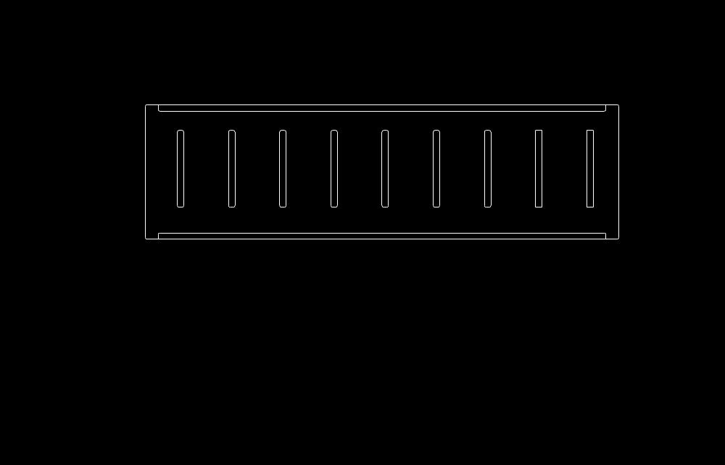
Interconnect Slot
End Termination

Cell Space

If soldering touch-up work needs to be done once the cells are placed on the substrate make sure that the substrate doesn’t get to much heat such that the heat damages the kapton or substrate. When soldering wires to the end terminations, be careful not to reheat the connection between the end termination and the interconnect from the cells such that previously done connection goes bad. These ideas should cover the assembly of the solar cell strings. One item of note is that these solder joints should be well cleaned with a Q-tip. Use two solutions to clean the cells. These two solutions should include first Acetone and then Iso-Propyl Alcohol (IPA).

Array Layout
Once the strings have been connected together they will need to be prepared to be lain out on the substrate of the Solar Panel. This preparation includes examining the cells to make sure that the cracks that have developed are not too critical. TECSTAR was confident in saying that cracks will occur at this point in time. It is quite definite that they will be present. The hope is that all of the cracks run parallel to the flow of current rather than perpendicular to the current flow. If the cracks run parallel to the flow of current, there shouldn’t be a problem, but if the cracks are more than a quarter across the cell it should be replaced. If there is a ding in a corner of the cell that shouldn’t be a problem either. See the following figure for details.
Before the front of the solar cells can be examined the solar cells must be taken from the off of the assembly block and flipped so that the bottom side is down. Getting a sturdy material that can be used as a strong back and placing it over the assembled sting can do this. The entire combination including the sting, the strong back and the assembly block can now be flipped over together so that the string assembly is now side up. From here the coverglass of the solar cells can be examined so that the cracks that were referenced to in the proceeding paragraph may be looked for.

Cracks are acceptable.
Cracks are unacceptable.

The separate strings for each panel will now be joined together so that the entire panel can be manufactured. In order to accomplish this the first thing that must be done is to plot two 1:1 copies of the panel on mylar. Vellum can be used rather than mylar, but mylar is the best material that can be used. What needs to now be done is that the strings should be placed on one copy of the panel in the exact location that they are to occupy. The top of the cell should be face up, so that the strings lay flat. These should then be taped together with kapton tape so that each string is connected to the string next to it.

Kapton Tape

Take the other sheet of mylar and punch two holes in each of the spaces for the solar cells so that the holes line up horizontally. These holes will be important for connecting the cells together.
Holes punched out
Mylar sheet with 1:1 solar array

It may be necessary to make cutouts in the mylar sheet for the interconnects as well. This was not something that was discussed at TECSTAR, but in thinking further about it, it may be necessary to get the mylar to lay flat on the tops of the solar cells. Strips of Kapton tape are placed on the sheet over the holes. This would mean that the holes must not be in line with the interconnects or else the tape would have to arch over the interconnects rather than laying down flat. A Q-tip is then used to affix the kapton tape through the holes of the mylar to the tops of the solar cells on the other side. Apply enough pressure with the Q-tip to affix the coverglass of the solar cell to the kapton strips of tape. This will allow the assembler to pick up the solar cells with the bottoms of the cells exposed so that it can be eventually placed upon the substrate.
Kapton tape stripes
Directly over holes, touching coverglass.

- 5 -

Either at this time, or else when the strings of solar cells are still on the assembly block the backs of the solar cells should be cleaned. This cleaning process will include first a clean with Acetone and then a clean with IPA, which should be done three times before proceeding. This is something that is necessary to insure that there is a good surface for the primer to be applied to.

Preparing the Substrate
As the preparations are made for the backs of the solar cells to be affixed to the substrate, the substrate must also be prepared for priming as well. All of these processes should be done in as clean of an environment as is possible. TECSTAR recommended that work be accomplished in a class 10,000 environment, although they said that a class 100,000 would probably be acceptable.
There needs to be a dielectric check performed on the substrate. The dielectric check will insure that there is not any leakage of charge through the Kapton, so that the backs of the solar cells are certain to be electrically isolated. This can be done with a megometer and alcohol or water. Do not use water because it takes longer to dry than alcohol; wait 24 hours after applying water to insure that all of it has dried. The Kapton layer on top of the substrate should be 2 mils thick. Apply alcohol evenly to the substrate and then slowly pass the probe of the megometer over the entire surface to know if charge is leaking through the Kapton. If there is a problem with charge leaking there must be a new layer of Kapton applied to the substrate. Once this has been done a very thorough cleaning of the substrate must be conducted. To clean use a Q-tip and wipe in a pattern where all of the wiping is in on direction and then all of the wiping is done in a perpendicular direction to that. This pattern should be employed rather than a circular pattern for all cleaning applications. The circular pattern will not clean, it will only spread the dust and other particles around the surface to be cleaned.
The cells and the substrate should be primed at the same time. Use SP 120 or SP 121, either of which can be purchased from Nusil. Wait at least two hours before applying the epoxy, but no more than 18 hours, this is the window in which the primer will produce the strongest bond. This should all take place in the clean room that was specified earlier.
Another test that should be done on the substrate is to put it through four cycles with a thermal vacuum. Use the temperature limits that the satellite will see as the limits for the thermal cycle. If the Kapton layer stays well sealed to the substrate, there should not be a problem with the bond strength between the Kapton and the aluminum substrate. Make certain to use space-grade Kapton for the dielectric layer. The epoxy to bond the Kapton to the substrate should be CV 2289.

Bonding the Assembly
Once the cells and the substrate have been primed the next step is to bond the cells to the substrate. TECSTAR, as well as most other solar cell manufacturers, use an epoxy called CV 2568 or some other variation of that epoxy. Before the trip to TECSTAR it was the intent of ION-F to use a version of the CV 2568 epoxy for the satellites, however TECSTAR felt that a CV 1142 would meet the needs of ION-F. CV 1142 is not as complicated to use to bond as the CV 2568 because it is a one-part epoxy and the CV 2568 is a two-part epoxy. CV 1142 has a longer working time, about four hours, compared to an hour with CV 2568. Marshall Cannedy pointed out the problem with CV 1142 because its bond line doesn’t hold as well as the bond line of the CV 2568. As such, the CV 2568 will be utilized as was originally planned for the bonding of the solar arrays to the substrate.
To prepare the CV 2568 for bonding the two-part mixture needs to be mixed together in the proper ratio. Once this has been done it is necessary to place the mixture under a vacuum to remove all of the bubbles from the bond material that were created when the two parts were combined together. After this has been finished it is necessary to begin bonding as there will not be a lot of time to waste.
In order to do the bonding the substrate needs to be prepared before this has happened. The name of the method used to apply the bond material is called skiving. To set up the substrate for skiving there must be a grid of Kapton tape affixed to the substrate in a pattern such that the proper amount of epoxy will be on the substrate in the proper positions. Normally the size of the patch of epoxy per solar cell should be 70% of the area of the solar cell that would be put onto it. A bond line of 6 mils is desired, so three stripes of 2-mil Kapton can be placed on top of each other to allow for 6 mils of clearance above the surface of the substrate. This grid is depicted in the figure below. A full-sized drawing of this grid pattern should be plotted out for referencing the necessary layout of the Kapton tape.
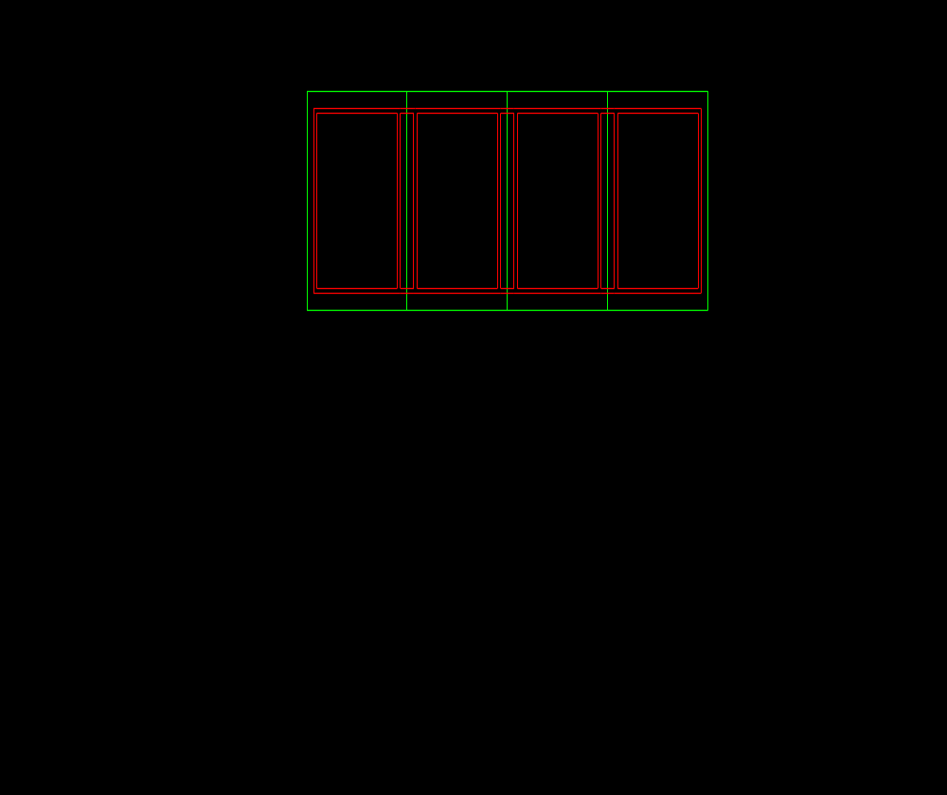
Size of Solar Cell
Kapton Epoxy Guide, 70% of Cell Area.

Place the enough epoxy within each square of the grid necessary to evenly fill the squares with epoxy. A skiving tool will be used to evenly distribute the epoxy so that it is exactly level with the top of the Kapton tape grids. A picture of a possible skiving tool is included below. This tool does not have to be done in exactly this manner; it merely needs to be something with which it is possible to pull the epoxy across the square of the grid. It might be helpful to have a tool that will bridge the gap of the grid in the small way, but not in the long way. This tool can be made out of aluminum or even some sort of plastic.
Skiving tool

Once the epoxy has been laid in the proper fashion the next step is to remove the Kapton grid from the surface of the substrate. The solar cells should now be placed on the substrate in its final position. The solar cells are still affixed to the mylar plot of the solar cell layout by the Kapton tape that makes contact with the tops of the solar cells through the holes that were punched out of the mylar. It will be possible to maneuver the solar cells to their proper position because the bottoms of the cells will be exposed. The edges of the substrate should be bordered with acrylic (or some other plastic) at this point in time so that under vacuum conditions the substrate will not receive any undue stresses. The following figure depicts the set-up for the vacuum bag that should be used to uniformly bond the cells. The desired pressure for the bond is 12 inches of water, which should be held for 18 hours. A bit of the adhesive should be cured in a tin cup alongside the panel assembly, indicating the relative characteristics of the assembly bond. This will complete the process necessary to assemble the solar panels.
Vacuum Bag

Hard Back

Mylar

Solar Cells

CV 2568
Kapton

CV 2289

Aluminum Panel

Wiring Specifications
The wiring should be either 24-gauge or 22-gauge wire. 22-gauge is probably generous, because the 24 gauge wires should be able to work for our purposes. It is possible to get away with 26-gauge wire for an individual string going from four cells to the rest of the string. TECSTAR used Raychem wire, the part number is M22-759-
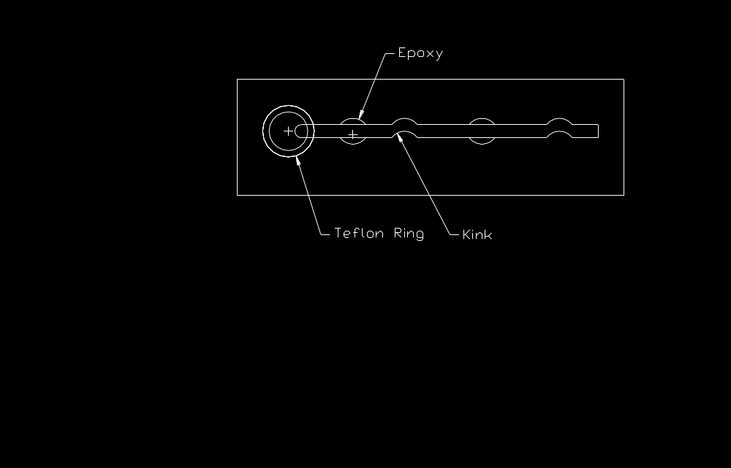
44/ (gauge, ‘22’, for instance). This normally comes in a white jacket, but it can come in any color, such as black and red for positive and negative voltage wiring. The wiring can be lain along the front of the panel, if that is necessary. The easiest way to run the wiring through the panel is to drill holes. These holes should have a telfon ring to have the wire rub against the ring rather than against the aluminum of the panel. The wires should be crimped every four inches and then affixed to the panel between the crimps by a dot of adhesive. You can use a Q-tip for the model to crimp the wire around it. The following figure contains an example of the necessary wiring configurations. The 4-inch spaced crimp is necessary because of expansion issues due to changes of temperature
that the wire will experience.

Testing
There are several tests that should be run for the solar cell assembly and then to test the capability of the solar cells. The tests that should be run for the solar cell assembly process should include the following. There is going to be a couple of test runs with CV 2568 and the bond process to ensure that the proper way of bonding has been established. These tests could be done initially with aluminum plates rather than solar cells to be certain that the bond process is comfortable. ION-F is in the process of talking with TECSTAR about the possibilities of getting mechanical cells for test purposes. Soldering processes need to be outlined and extensively tested. It would be conceivable useful to do the largest array with plain aluminum plates rather than solar cells to start with.
To test that the solar cells are functioning well there needs to be some sort of light source. TECSTAR felt that it would be easier and more accurate to go outdoors to use the sun as a light source rather than using special lighting. TECSTAR and TRW both use a Xenon light source with filters to simulate the light of the sun. A normal halogen lamp will not work well because the frequencies of light are not the same as sunlight. The best time to test the solar cells is between 11:00 a.m. and 1:00 p.m. Because of the angle of the earth during wintertime the solar cells will not see one sun, but it is possible to measure the amount of sunlight and it should be at an intensity of .7 suns.

